

Phishing Detection Extension
Proof of Concept.

CIS-4951 SENIOR DESIGN PROJECT II
Spring 2025
Professor: Dr. Sadjadi

Project Team

Ezekiel Garcia
Jonathan Iglesias
Giovani Labrador
Tristin Liebenberg
Eyaan Syed

Table of Contents
PROJECT DOCUMENTATION 2
PHISHING DETECTION EXTENSION – PROOF OF CONCEPT. 2
INTRODUCTION 2
CYBERSECURITY-RELATED THREATS IDENTIFICATION 2
THREAT IDENTIFICATION IN OUR SYSTEM 3
HANDLING CYBERSECURITY THREATS 4
RESPONSE PLAN 4
RECOVERY PLAN 5
RISK ANALYSIS 5
SYSTEM REQUIREMENTS 5
SYSTEM DESIGN 7
METHDOLOGY 7
TESTING AND RESULTS 10
CONCLUSION 11
REFERENCES 12
APPENDIX 13
Appendix “A”. Velocity Chart 13
Appendix “B”. README.txt 14
Appendix “C”. Code 15

PROJECT DOCUMENTATION

PHISHING DETECTION EXTENSION – PROOF OF CONCEPT.

INTRODUCTION
The goal of this program is to detect phishing attempts by analyzing URLs for specific indicators using Java. It employs a straightforward rule-based approach, including methods such as detecting suspicious keywords, examining URL lengths, and identifying patterns like the presence of IP addresses or insecure protocols (e.g., HTTP). By implementing these simple yet effective techniques, the program aims to flag potential phishing URLs and enhance user security.

CYBERSECURITY-RELATED THREATS IDENTIFICATION
Understanding Phishing Threats
Phishing is recognized as one of the most prevalent and damaging cybersecurity threats in the digital world. Cybercriminals craft fraudulent communications—such as emails, websites, or text messages—that impersonate legitimate entities to deceive victims. The ultimate goal is to extract sensitive information such as usernames, passwords, credit card numbers, or other confidential data, often resulting in financial loss or identity theft. Phishing attacks can also be identified using machine learning models that analyze URL patterns and content (Dutta, 2021).
Email-Based Phishing
Among the most common phishing techniques, attackers use emails pretending to originate from trusted organizations like banks, tech companies, or government agencies. These emails often carry a sense of urgency or fear to prompt users into taking immediate actions, such as clicking a link or providing their credentials.
URL-Based Phishing
Phishing communications frequently include URLs that direct victims to fraudulent websites designed to mimic legitimate ones. These URLs often exhibit suspicious patterns, such as:
Phishing often uses deceptive URLs to direct victims to fraudulent websites that appear to be legitimate. Some key characteristics of phishing URLs include:
- Use of IP addresses instead of domain names.
- Excessive subdomains to obscure the actual source of the link.
- Absence of HTTPS protocols, indicating insecure connections.
Key Indicators of Phishing
Phishing attacks typically include the following red flags:
- Keywords like "verify," "update," or "secure."
- Urgent messaging (e.g., "Act now!" or "Your account will be locked").
- Slight alterations in domain names (e.g., "g00gle.com" instead of "google.com").

THREAT IDENTIFICATION IN OUR SYSTEM
The rule-based phishing detection system analyzes emails and URLs to identify such threats through:
- Keyword Scanning: Detects the presence of phishing-specific words in email content.
- URL Examination: Flags link with insecure protocols (HTTP), long and complex structures, or embedded IP addresses.
- Pattern Analysis: Identifies phishing tactics like misleading subdomains or inconsistent sender information.

Industry Context While advanced phishing detection systems utilize behavioral analytics, machine learning, or even deep learning, rule-based systems remain foundational for threat identification. For instance, lexical analysis combined with visual similarity has been shown to improve phishing detection accuracy in real-time environments (Gnanesh et al., 2025). Similarly, deep learning models, as demonstrated by (Mughaid et al. 2022), can intelligently analyze complex patterns to detect sophisticated phishing tactics. However, in small-scale or educational projects, rule-based systems provide a practical and effective approach to mitigating phishing risks.

Real-World Impact Cybersecurity threats like phishing are a major challenge for individuals and organizations, leading to financial losses, data breaches, and reputational damage. Machine learning-based methods, like those described by (Dutta, 2021), offer a sophisticated alternative to identifying phishing attacks by analyzing URL patterns and content. However, lightweight systems can still offer significant value, providing a robust first line of defense against these threats for users who may lack access to advanced tools.

HANDLING CYBERSECURITY THREATS
Detection and Analysis:
The project adopts an industry-inspired approach to threat detection by applying predefined rules to analyze emails and URLs:
- Keyword Matching: Detects phishing keywords like "login," "verify," and "update."
- URL Security Check: Flags suspicious links using HTTP protocols or abnormal patterns, such as IP addresses and subdomains.
- Pattern Recognition: Examines the overall structure for inconsistencies, including unusual URL lengths.

Industry Correlation In real-world systems, threat detection is often achieved through proactive monitoring and reactive solutions, reflecting these principles by:
- Actively flagging potential threats in a simulated environment.
- User Preparedness: Equipping users to recognize and handle malicious content through awareness and alerts.

Mitigation Measures
- Flagging: Emails matching phishing criteria are quarantined or flagged for manual review.
- Educational Benefit: Alerts users about suspicious behaviors, fostering greater awareness and reducing phishing risks.

RESPONSE PLAN
Notification System Flagged emails are promptly categorized as "Potentially Phishing," accompanied by clear warnings for the user. This mirrors industry standards, where user awareness is key to preventing harm.

Manual Review Option Suspicious emails are quarantined for additional inspection. This allows:
- Verification of the legitimacy of flagged emails.
- A reduction in the risks associated with interacting with malicious content.
User Guidance The system provides users with actionable advice, including:
- Avoiding interaction with flagged links or emails.
- Reporting phishing attempts to relevant authorities or administrators.

RECOVERY PLAN
Incident Response The project focuses on minimizing user exposure and mitigating damage through:
- A secure environment where users can safely learn to recognize phishing threats.
- Early detection mechanisms to prevent harmful interactions.
Improvement Strategies
- Detection rules are continuously updated to incorporate lessons learned from flagged threats.
- Regular updates ensure the system remains effective in combating new phishing techniques.

RISK ANALYSIS
Key Risks in the System
- False Positives: Legitimate emails flagged due to similarities with phishing patterns.
- False Negatives: Sophisticated phishing attempts bypass detection.
- Scalability: Rule-based systems may struggle with increasingly advanced tactics.
Risk Mitigation
- Regular Updates: Continuously revising keyword databases and detection rules.
- Extensive Testing: Utilizing diverse phishing samples to enhance reliability.
- Clear Notifications: Informing users about flagged emails to reduce the impact of false positives.

SYSTEM REQUIREMENTS

Hardware
- A standard computer with basic specifications, such as:
  - Processor: Dual-core or higher
  - Memory: 4GB RAM or more
  - Storage: At least 100MB free space for project files

Software: a simpler setup might only need a text editor and the Java compiler, while larger teams may prefer feature-rich IDEs like IntelliJ IDEA.
- Java Development Kit (JDK): JDK 8 or higher (recommended version: JDK 11 or later for compatibility and performance).
- Integrated Development Environment (IDE):
  - Use any Java-compatible IDE such as:
    - IntelliJ IDEA
    - Eclipse
    - VSCode
  - Alternatively, a text editor like Sublime Text or Notepad++ can be used alongside the Java compiler.

Libraries: The absence of external library requirements aligns with our goal of simplicity. However, even within this scope, the chosen libraries (like java.util.regex or optional ones like Apache Commons) depend on the program's specific needs for string processing, pattern matching, or performance optimization.
- The project does not strictly require external libraries. However, the following can enhance functionality if needed:
  - java.util.regex: For regular expressions to match patterns in URLs (part of Java's standard library).
  - Apache Commons StringUtils (optional): For advanced string manipulation, such as checking for substrings or analyzing URL content.

SYSTEM DESIGN
The project is designed to employ a rule-based approach to phishing detection, focusing on simplicity and practicality. The main components of the system include:  - Input Module:  - Accepts user-provided emails or URLs for analysis.  - Detection Module:  - Implements predefined rules to analyze emails and URLs based on:  - Keywords (e.g., "verify," "update").  - URL patterns (e.g., excessive subdomains, HTTP protocols).  - Structural inconsistencies (e.g., long or unusual URLs).  - Output Module:  - Flags potentially phishing threats by providing clear notifications or quarantining suspicious emails/URLs. | 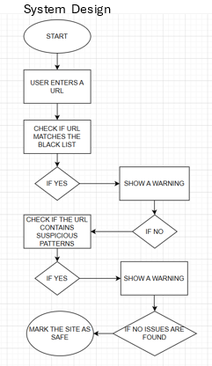

METHDOLOGY
Our index.html file serves as the frontend interface of your phishing detection tool. It provides users with a clean, simple, and responsive layout to interact with two main features: URL scanning and Email content analysis. This UI is a core part of the proof of concept, allowing non-technical users to input potentially suspicious content and receive threat insights with ease.
In the <head> section of our code, we define a modern look using CSS with a minimalist and user-friendly design. The design gives the dashboard a polished appearance by utilizing rounded shapes, subdued hues, and gentle shadows. This design decision improves usability and mimics the appearance of a real-world browser extension user interface. We have utilized a semantic HTML structure (e.g., header, nav, div.container) to keep things accessible and maintainable.
Our navigation bar provides two tabs:
- URL Scan
- Email Text Scan
This is a classic tab-based navigation pattern, implemented with a small JavaScript function switchTab(tabId, btn).
URL Scan:
- Users can input one or more URLs separated by semicolons . Once submitted, the scanUrls() function kicks off a scan process by communicating with the backend proxy server for:
  - VirusTotal (checks the URL against multiple antivirus engines)
  - AbuseIPDB (checks if the domain’s IP has a history of abuse reports)
Email Text Scan:
Users can paste raw email text in this field. The script extracts every URL from the email body using a regular expression, then passes each URL through the same scanning pipeline as before. One of the main applications for browser security technologies is the simulation of real-world phishing detection from email bodies.
Javascript Logic:
API Request Functions:
- scanWithProxy(url) sends the URL to your local proxy for VirusTotal analysis.
- scanWithAbuseIPDB(domain) sends the domain (or IP) for reputation checking.
Result Builders:
- buildVirusTotalSection() builds HTML output summarizing the VirusTotal scan results, including how many engines flagged it as malicious or suspicious.
- buildAbuseIPDBSection() summarizes the abuse score and additional data like country and ISP.
Scanning Functions:
- scanUrls() parses and sends each URL for scanning, displaying results in real time.
- scanEmailText() does the same, but first extracts URLs from pasted email content.
By separating data gathering from UI rendering (build...Section functions), you're following good separation of concerns methodology — essential for maintainable and testable code.
The package.json file is the configuration blueprint for our Node.js backend. It describes the project’s metadata, scripts, and the external libraries (dependencies) it relies on. For our phishing detection tool, this file ensures the necessary modules are available to interact with external APIs like VirusTotal and AbuseIPDB securely and efficiently.
From a development standpoint, using package.json helps ensure:
- Reproducibility: Anyone can install dependencies using Node Package Manager, (NPM) install and run your backend without needing to manually configure anything.
- Modularity: The backend is cleanly separated from the frontend. The client makes simple requests to a local API, which then talks to external services. This is more secure and scalable.
- Professional Practice: Even as a proof of concept, this setup mimics real-world architectures — where API keys are hidden on the server and communication is layered for security and control.
At a high level, server.js acts as a proxy server between our frontend (the HTML app) and external threat intelligence APIs. This is important because APIs like VirusTotal and AbuseIPDB require API keys, which should never be exposed on the client side. By sending requests from the backend instead, we can:
- Keep API keys safe
- Bypass browser-origin CORS restrictions
- Control and sanitize inputs before hitting external services
VirusTotal Scan:
When a user scans a URL, the frontend calls this endpoint. Here's how it works:
- Submits the URL to VirusTotal’s /urls endpoint.
- Waits 3 seconds (using setTimeout) to allow VirusTotal to analyze the URL.
- Fetches the analysis report using the scan ID.
- Encodes the URL and fetches the final report using VirusTotal’s /urls/:id endpoint.
The server then returns both the raw analysis and the final structured result to the frontend.
The 3-second timeout is a simple (but clever) solution to VirusTotal’s asynchronous scan flow. A full version might poll for readiness instead, but this is sufficient and realistic for a proof of concept.
AbuselPDB Lookup:
When scanning for a URL, AbuselPDB executes the following:
- Resolves a domain (e.g., example.com) to its IP address using Node’s DNS module.
- Sends the IP to AbuseIPDB’s /check endpoint to fetch its abuse confidence score, ISP, and more.
- Returns this data to the frontend to be rendered in the results panel.
Using AbuseIPDB adds another layer of insight by checking the domain/IP's reputation history.

TESTING AND RESULTS

Testing Methodology
The system underwent comprehensive testing to ensure its effectiveness, accuracy, and reliability. The testing process consisted of the following phases:
- Unit Testing:
  - Each module (e.g., URL parsing, keyword matching, security checks) was tested independently.
  - Focused on validating the correctness of individual functionalities.
- Integration Testing:
  - Ensured seamless interaction between different components, such as detection rules and the notification system.
  - Verified that input from one module (e.g., parsed URLs) was correctly processed by subsequent modules.
- Simulated Phishing Scenarios:
  - A collection of real-world and artificially generated phishing examples was used to test the system’s ability to detect threats.
  - Scenarios included:
    - Emails containing phishing keywords.
    - URLs with insecure protocols, IP addresses, or excessive subdomains.
    - Legitimate content to test for false positives.
After testing, several potential enhancements have been identified to improve the system’s functionality and usability:

1. Add More Detection Rules
- Expand the rule set to address sophisticated phishing tactics, such as:
  - Analyzing email headers for spoofed sender information.
  - Detecting links hidden in email attachments or image-based phishing attempts.
- Incorporate more patterns to reduce the likelihood of false negatives.

2. Include a User-Friendly Interface
- Develop a Graphical User Interface (GUI) to make the system accessible to non-technical users.
  - Features could include:
    - Drag-and-drop functionality for submitting emails or URLs.
    - Visual warnings with clear explanations for flagged threats.
    - Logs for users to review flagged items and understand detection results.
- Use JavaFX or Swing to implement a lightweight and interactive GUI.

3. Connect to a Database of Known Phishing URLs
- Integrate a database (e.g., SQLite or an external phishing URL API) to cross-check analyzed URLs with a repository of known threats.
  - This addition would enhance detection accuracy by identifying URLs already flagged as phishing attempts.
  - Regularly update the database to keep up with evolving threats.

4. Real-Time Monitoring
- Extend functionality to monitor user activity in real-time (e.g., browser extensions to analyze links before they’re clicked).
- Provide instant alerts when suspicious URLs are detected, reducing potential harm.

5. Add Multilingual Support
- Enhance the keyword detection system by supporting multiple languages to detect phishing attempts across diverse user bases.

6. Advanced Reporting Features
- Offer users detailed reports of flagged threats, including:
  - Detected indicators (e.g., keywords, insecure protocols).
  - Suggestions for avoiding similar threats in the future.
- Enable exporting of logs for further analysis or reporting to cybersecurity authorities.

7. Improve Scalability
- Refactor the system to handle larger volumes of data efficiently, preparing it for potential future use in enterprise environments.

CONCLUSION
The "Proof of Concept" for a phishing detection extension successfully demonstrates the feasibility of a rule-based approach to identifying phishing threats. By focusing on keyword detection, URL analysis, and predefined security checks, the project provides a lightweight and practical solution for enhancing user security in a controlled environment.
While the system is effective at detecting common phishing techniques, the testing phase highlighted areas for potential improvement, such as addressing obfuscated phishing methods and refining detection rules to reduce false positives and negatives. These insights pave the way for future enhancements, including the integration of dynamic databases, advanced user interfaces, and real-time monitoring capabilities.
This project serves as a foundational step toward developing a robust phishing detection tool. It not only showcases the core functionality of threat detection but also emphasizes the importance of user education and awareness in mitigating cybersecurity risks.

REFERENCES
- Dutta, A. K. (2021). Detecting phishing websites using machine learning techniques. PLOS ONE, 16(10), e0258361. https://journals.plos.org/plosone/article?id=10.1371/journal.pone.0258361
- Gnanesh, A., Deepesh, D. A., Hegde, B., Vyasamudri, S., & Sarasvathi, V. (2025). Real-time phishing detection using lexical analysis and visual similarity. Broadband Communications, Networks, and Systems (BROADNETS 2024). https://link.springer.com/chapter/10.1007/978-3-031-81168-5_15
- Mughaid, A., AlZu’bi, S., Hnaif, A., Taamneh, S., Alnajjar, A., & Abu Elsoud, E. (2022). An intelligent cybersecurity phishing detection system using deep learning techniques. Cluster Computing, 25, 3819–3828. https://link.springer.com/content/pdf/10.1007/s10586-022-03604-4.pdf

APPENDIX

Appendix “A”. Velocity Chart

The projected average velocity for the project was 126.67 hours, and the achieved velocity has been 136.91 hours, demonstrating a remarkable 8.07% improvement in velocity.
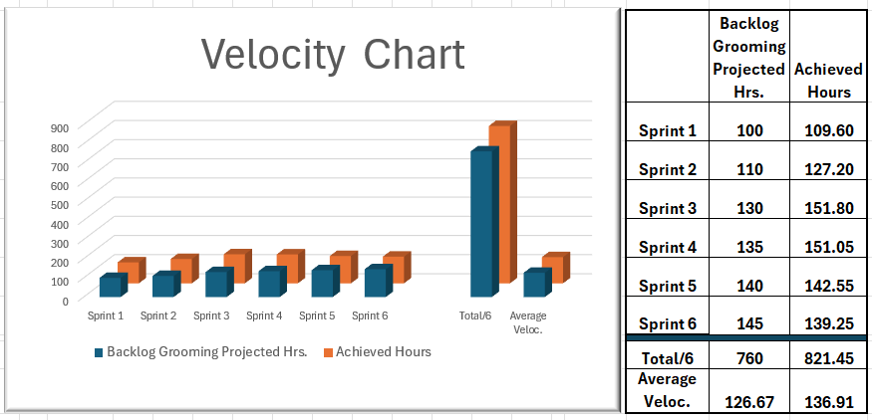

Appendix “B”. README.txt

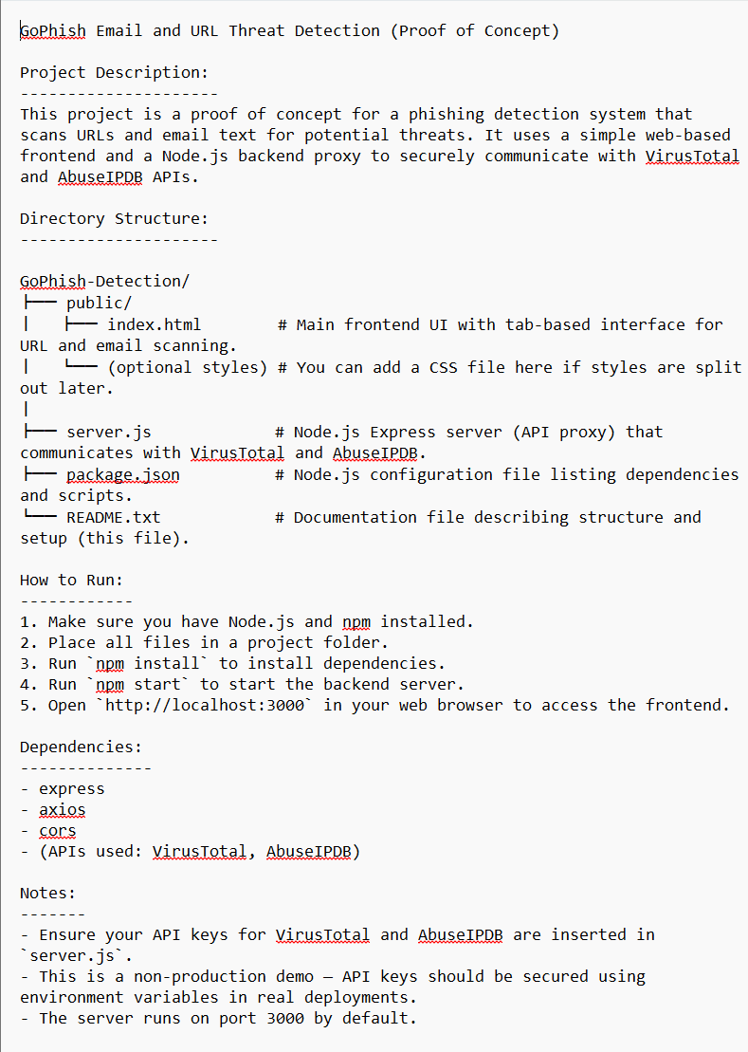

Appendix “C”. Code
Include the complete source code for the phishing detection extension. Make sure to:
Index.html
<!DOCTYPE html>
<html lang="en">
<head>
<meta charset="UTF-8">
<title>GoPhish-Email-and-URL-Threat-Detection</title>
<style>
body {
font-family: 'Segoe UI', Tahoma, Geneva, Verdana, sans-serif;
margin: 0;
background-color: #f4f6f8;
color: #333;
}
header {
background-color: #2c3e50;
color: white;
padding: 20px;
text-align: center;
box-shadow: 0 2px 4px rgba(0, 0, 0, 0.1);
}
nav {
display: flex;
justify-content: center;
background-color: #ecf0f1;
padding: 10px 0;
border-bottom: 1px solid #ccc;
}
button.tab {
background-color: transparent;
border: none;
font-size: 16px;
font-weight: bold;
margin: 0 15px;
padding: 10px 20px;
cursor: pointer;
color: #2c3e50;
border-bottom: 2px solid transparent;
}
button.tab:hover, button.tab.active {
border-bottom: 2px solid #2980b9;
color: #2980b9;
}
.container {
max-width: 900px;
margin: 40px auto;
background-color: white;
padding: 30px;
box-shadow: 0 4px 12px rgba(0, 0, 0, 0.1);
border-radius: 8px;
}
h2, h3 {
margin-bottom: 10px;
}
input, textarea, button.action {
padding: 12px;
margin: 10px 0;
width: 100%;
font-size: 16px;
border: 1px solid #ccc;
border-radius: 5px;
}
button.action {
background-color: #3498db;
color: white;
border: none;
cursor: pointer;
}
button.action:hover {
background-color: #2980b9;
}
.tab-content { display: none; }
.active { display: block; }
.loading { font-style: italic; color: gray; }
.malicious { color: red; }
.suspicious { color: orange; }
.clean { color: green; }
.vendor-malicious { color: red; }
.vendor-suspicious { color: orange; }
.vendor-harmless { color: green; }
.result-block {
border: 1px solid #ddd;
padding: 15px;
margin-bottom: 20px;
border-radius: 5px;
background: #fafafa;
}
</style>
</head>
<body>
<header>
<h1>GoPhish Email and URL Threat Detection</h1>
<p>Analyze URLs and Email Content for Potential Threats</p>
</header>

<nav>
<button class="tab active" onclick="switchTab('urlTab', this)">URL Scan</button>
<button class="tab" onclick="switchTab('emailTab', this)">Email Text Scan</button>
</nav>

<div class="container">
<div id="urlTab" class="tab-content active">
<h2>URL Scan</h2>
<input type="text" id="urlInput" placeholder="Enter one or more URLs separated by a semicolon (;)" />
<button class="action" onclick="scanUrls()">Scan URLs</button>
<div id="urlResult"></div>
</div>

<div id="emailTab" class="tab-content">
<h2>Email Text Scan</h2>
<textarea id="emailInput" rows="8" placeholder="Paste email text here..."></textarea>
<button class="action" onclick="scanEmailText()">Scan URLs in Email</button>
<div id="emailResult"></div>
</div>
</div>

<script>
function switchTab(tabId, btn) {
document.querySelectorAll('.tab-content').forEach(el => el.classList.remove('active'));
document.querySelectorAll('button.tab').forEach(b => b.classList.remove('active'));
document.getElementById(tabId).classList.add('active');
btn.classList.add('active');
}

async function scanWithProxy(url) {
const res = await fetch('/api/virustotal', {
method: 'POST',
headers: { 'Content-Type': 'application/json' },
body: JSON.stringify({ url })
});
return await res.json();
}

async function scanWithAbuseIPDB(domain) {
const res = await fetch('/api/abuseipdb', {
method: 'POST',
headers: { 'Content-Type': 'application/json' },
body: JSON.stringify({ ip: domain })
});
return await res.json();
}

function buildVirusTotalSection(url, data) {
const results = data.final.data.attributes.last_analysis_results;
let malicious = 0, suspicious = 0, vendors = [];

for (const engine in results) {
const category = results[engine].category;
if (category === 'malicious') malicious++;
if (category === 'suspicious') suspicious++;
vendors.push({ engine, category });
}

const className = malicious > 0 ? 'malicious' : suspicious > 0 ? 'suspicious' : 'clean';
const vendorInfo = vendors.map(v =>
`<span class="vendor-${v.category}">- ${v.engine}: ${v.category}</span>`
).join('<br>');

const reportId = data.final.data.id ?? 'UNKNOWN';

return `
<div class="result-block ${className}">
<strong>VirusTotal Result for ${url}</strong><br>
Malicious: ${malicious} | Suspicious: ${suspicious}<br>
<details><summary>Advanced Scan Information</summary>
${vendorInfo}
</details>
<a href="https://www.virustotal.com/gui/url/${reportId}" target="_blank">View full report</a>
</div>
`;
}

function buildAbuseIPDBSection(ip, data) {
const abuseScore = data.abuseConfidenceScore || 0;
const className = abuseScore >= 50 ? 'malicious' : abuseScore > 0 ? 'suspicious' : 'clean';
return `
<div class="result-block ${className}">
<strong>AbuseIPDB Result for ${ip}</strong><br>
Abuse Score: ${abuseScore}%<br>
Country: ${data.countryCode}<br>
ISP: ${data.isp}<br>
<details><summary>Advanced Scan Information</summary>
<pre>${JSON.stringify(data, null, 2)}</pre>
</details>
</div>
`;
}

async function scanUrls() {
const input = document.getElementById("urlInput").value;
const urls = input.split(';').map(u => u.trim()).filter(Boolean);
const resultDiv = document.getElementById("urlResult");
resultDiv.innerHTML = "<div class='loading'>Scanning...</div>";
let output = "";
for (const url of urls) {
try {
const domain = new URL(url).hostname;
const vtData = await scanWithProxy(url);
const ipData = await scanWithAbuseIPDB(domain);
output += buildVirusTotalSection(url, vtData);
output += buildAbuseIPDBSection(domain, ipData);
} catch (err) {
output += `<div class="malicious">Error scanning ${url}: ${err.message}</div>`;
}
}
resultDiv.innerHTML = output;
}

async function scanEmailText() {
const input = document.getElementById("emailInput").value;
const urls = input.match(/https?:\/\/[\w.-]+(?:\.[\w.-]+)+(?:[\/\w?=&#%.-]*)/g) || [];
const resultDiv = document.getElementById("emailResult");
resultDiv.innerHTML = urls.length ? "<div class='loading'>Scanning...</div>" : "No URLs found.";
let output = "";
for (const url of urls) {
try {
const domain = new URL(url).hostname;
const vtData = await scanWithProxy(url);
const ipData = await scanWithAbuseIPDB(domain);
output += buildVirusTotalSection(url, vtData);
output += buildAbuseIPDBSection(domain, ipData);
} catch (err) {
output += `<div class="malicious">Error scanning ${url}: ${err.message}</div>`;
}
}
resultDiv.innerHTML = output;
}
</script>
</body>
</html>

Package.json

{
"name": "virustotal-proxy",
"version": "1.0.0",
"description": "Simple proxy for VirusTotal API requests",
"main": "server.js",
"scripts": {
"start": "node server.js"
},
"dependencies": {
"axios": "^1.6.0",
"cors": "^2.8.5",
"express": "^4.18.2"
}
}

Server.js

const express = require('express');
const axios = require('axios');
const cors = require('cors');
const path = require('path');
const dns = require('dns').promises;

const app = express();
const PORT = process.env.PORT || 3000;

const VT_API_KEY = '37245157627c004794c63aa38d7636914bad23b6a52ad21b2770b10ba0d06d4f';
const ABUSE_IP_KEY = '54014bb2293bc998ac3792bfc12c7a6c59caa50f0e81e5bbe697b56399d0036a50237789a7882672';

app.use(cors());
app.use(express.json());
app.use(express.static(path.join(__dirname, 'public')));

// VIRUSTOTAL ROUTE
app.post('/api/virustotal', async (req, res) => {
const { url } = req.body;
console.log('[VirusTotal] URL received:', url);

try {
const scanResponse = await axios.post(
'https://www.virustotal.com/api/v3/urls',
new URLSearchParams({ url }),
{
headers: {
'x-apikey': VT_API_KEY,
'Content-Type': 'application/x-www-form-urlencoded',
},
}
);

const scanId = scanResponse.data.data.id;
console.log('[VirusTotal] Scan submitted, ID:', scanId);

setTimeout(async () => {
try {
const analysis = await axios.get(
`https://www.virustotal.com/api/v3/analyses/${scanId}`,
{
headers: { 'x-apikey': VT_API_KEY },
}
);
console.log('[VirusTotal] Analysis completed. Fetching final report...');

const encodedUrl = Buffer.from(url).toString('base64').replace(/=+$/, '');
const finalReport = await axios.get(
`https://www.virustotal.com/api/v3/urls/${encodedUrl}`,
{
headers: { 'x-apikey': VT_API_KEY },
}
);

res.json({ analysis: analysis.data, final: finalReport.data });
} catch (error) {
console.error('[VirusTotal] Error retrieving scan report:', error.message);
res.status(500).json({ error: 'Failed to retrieve scan report' });
}
}, 3000);
} catch (error) {
console.error('[VirusTotal] Error submitting scan:', error.message);
res.status(500).json({ error: 'Failed to submit scan' });
}
});

// ABUSEIPDB ROUTE
app.post('/api/abuseipdb', async (req, res) => {
const { ip } = req.body;
console.log('[AbuseIPDB] Domain received for lookup:', ip);

try {
const addresses = await dns.lookup(ip, { all: true });
const ipAddress = addresses[0]?.address;
console.log('[AbuseIPDB] Resolved IP:', ipAddress);

if (!ipAddress) {
console.error('[AbuseIPDB] IP resolution failed.');
return res.status(400).json({ error: 'Failed to resolve IP from domain' });
}

const response = await axios.get('https://api.abuseipdb.com/api/v2/check', {
params: {
ipAddress,
maxAgeInDays: 90
},
headers: {
Key: ABUSE_IP_KEY,
Accept: 'application/json'
}
});

console.log('[AbuseIPDB] Abuse data retrieved for IP.');
res.json(response.data.data);
} catch (error) {
console.error('[AbuseIPDB] Request failed:', error.message);
res.status(500).json({ error: 'AbuseIPDB request failed' });
}
});

// FALLBACK FOR 404
app.use((req, res) => {
res.status(404).sendFile(path.join(__dirname, 'public', 'index.html'));
});

app.listen(PORT, () => {
console.log(`Server running on http://localhost:${PORT}`);
});

